**WEEK-3_EF Core 8.0_LAB6**

Lab 6: Updating and Deleting Records

Scenario:

The store updates product prices and removes discontinued items.

Objective:

Update and delete records using EF Core.

Steps:

1. Update a Product:

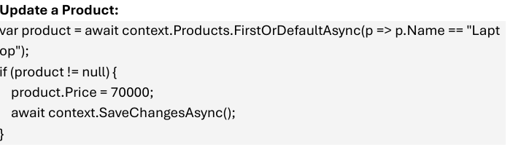

1. Delete a Product:

